# Steps in the Wireless Network Task

1. Wear the antistatic wrist band
2. Replace NIC with the WNIC
3. Go the workstation
4. Show the steps to install WNIC driver
   * Double click on the folder Capstone Jan23 on the desktop
   * Click on the Driver setup file, continue **BUT DON’T FINISH, ask your assessor to check**
5. **Connect Wireless Printer**

Show the steps to install Wireless printer

* + Double click on the folder Task Bii on the desktop
  + Click on the Driver setup file, continue **BUT DON’T FINISH, ask your assessor to check**

1. **Go update the helpdesk SW with the Faults & Rectification+ add a screenshot in the Network Plan document (Appendix B)**
2. Reset Router
3. **Connect to Router**
   * **Connect workstation to the default router**
4. **Open browser, type 192.168.0.1**

**With user :admin , password: admin**

1. **Change SSID to your name**

**Go to Wireless 🡪 Wireless Settings🡪**

* + **Wireless Network Name : your name**
  + **Enable Wireless Router Radio & SSID Broadcast**
  + **Save & Reconnect to the router with new SSID & old password**

1. **Change the password**

**Wireless🡪 Wireless Security🡪 change password to P@ssw0rd123**

1. **Change Security**

**WPA/WPA2 – Personal (Recommended) option**

* + **Version: WPA2-PSK**

**Save & Reconnect to the router with new SSID & new password**

1. **Go to DHCP & Setup the rage of IP Address as given**

**Enable 🡪 Save**

1. **Connect the workstation to the new SSID and test (ping) the network.**
2. **Got to CMD – ping 192.168.0.1- Check that the router is connected**

**Raise your hand for the assessor to check**

1. **Go the printer, connect the printer to the your SSID**

**Steps:**

* + At the Home Screen , Click Setup

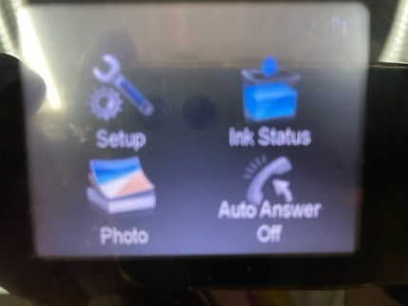

* + Network

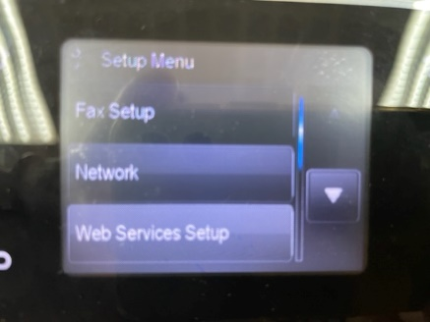

* + Wireless

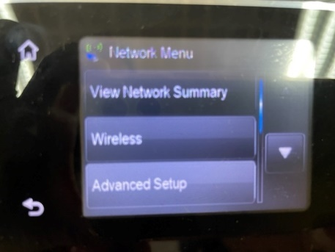

* + Wireless Setup Wizard

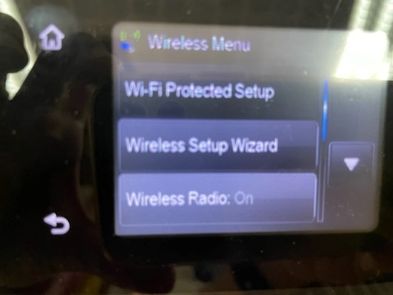

* + Continue

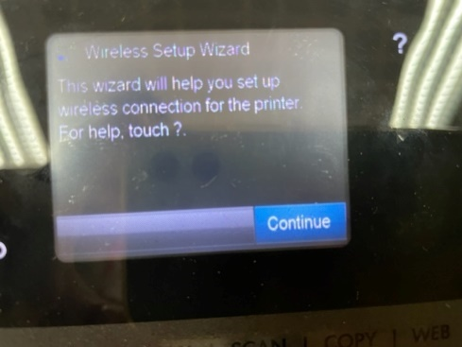

* + Wait until it finds the Task Bii SSID

